What would a queer world look like? It’s a simple question, one that a student posed two years ago during a class discussion of Martin Duberman’s polemic Has the Gay Movement Failed? “What would you change,” she asked, “if you could wave a queer magic wand?” But simple questions can dissemble. The other students were stumped. When I tried to answer, I found myself at a loss for words—even though what first drew me into queer studies was the discipline’s ability to proffer solutions to our world’s hidden ills.
As though it were yesterday, I still recall the visceral thrill of reading Michel Foucault’s The History of Sexuality, which I gulped down in a single afternoon sitting in the campus coffee shop. I remember researching queer literature as a college senior, discovering ancestors I never knew existed. These texts, which were part of my own coming out and coming to terms with my sexuality, held out a way of looking at the world beyond the humdrum of daily life. Much of that thrill was in critique, in tearing down the totems of established thought. When I was 22, I wasn’t worried about what might replace them. But by the time the student asked me that question—whether because I’m older or because of all that has transpired over the last six years—I was.
These questions are not merely my own, of course. They point to a deeper conflict within the academic fields that constitute queer studies: the tension between the critical impulse of queerness and its desire to enact positive political change. The source of this question, I’ve come to believe, is the inability of queer theory to conceive positively of the state—that is, to explain what the state is (or ought to be) and why it should exist. This problem stretches back to queer theory’s origins, and we can only begin to understand it by asking what, precisely, queerness is.
Once a slur, queer today is a convenient shorthand to refer to lesbian, gay, bisexual, trans and other sexually and gender-nonconforming people. It also carries political valences; those who identify as queer typically align with radical or progressive movements. Then there’s academic queerness—a range of humanistic fields from queer theory to gender studies to the history of sexuality. To these writers and scholars, among whom I count myself, queer denotes a set of methodological approaches to the study of sex, gender and sexuality shaped by the work of deconstructionist philosophers in the second half of the twentieth century, including Jacques Derrida, Gilles Deleuze and, most significantly, Foucault.
More good mail days.
Join our newsletter.
Foucault was above all else a theorist of power, by which he meant not the hierarchical domination exercised by states, but rather the normative expectations that shape our everyday lives. This new form of power emerged in the modern period through everyday interactions and social institutions, from prisons to schools to clinics. This conception of power was revolutionary, for it turned the common sense of what was “normal” on its head, insisting that what we assume to be typical is, in fact, nothing more than a social construct.
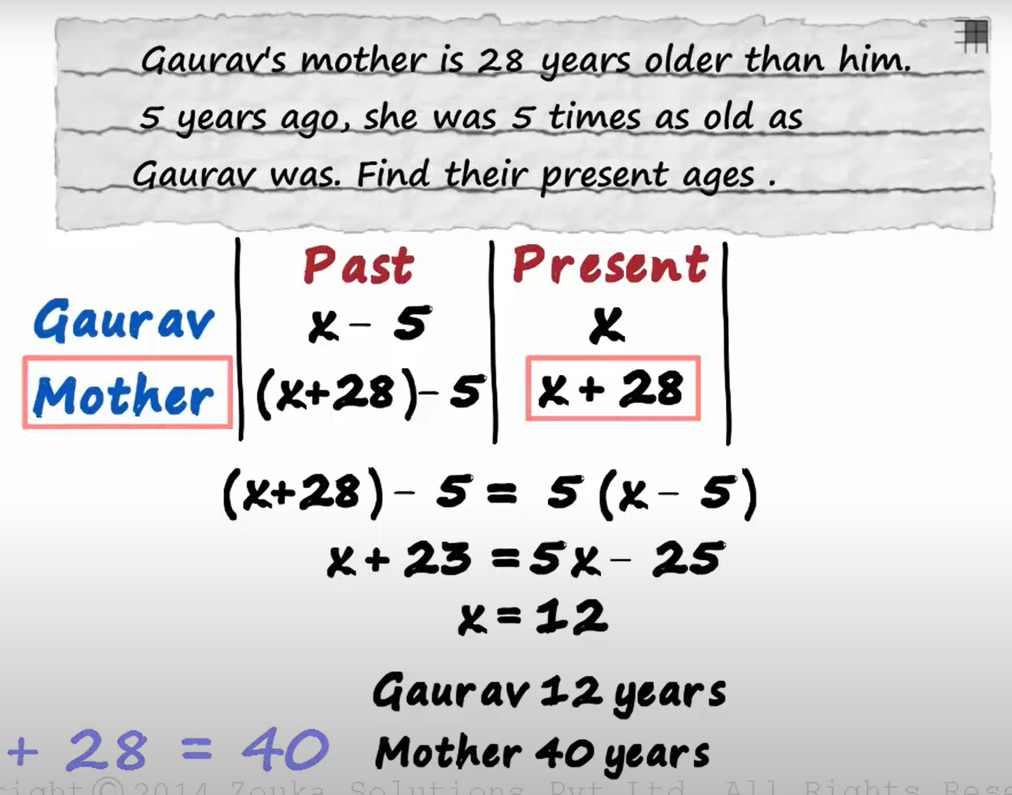

Strange, odd -queer
Puzzled, confused - stumped
Put forward, hold out, present , offer - proffer

